

STUDENT NAME: SHIVANI ADSAR

ASSIGNMENT: 1

Course Information

Course Title: Applications of Artificial Intelligence

Course Number EAI6010

Term and Year: Winter Part B:

Start and End Dates: March 2 – April 11th

After installing R and RStudio this assignment requires you to do the following:

* Read the customers.csv file provided to you on Canvas using the following code:

data <- read.csv(file = paste0(<your file path>,"Customers.csv"),

header = FALSE,

stringsAsFactors = FALSE,

na.strings = "")

Answer: The customers csv file was imported using the read function in R.

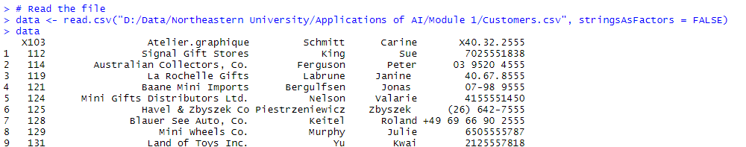

* Use the code below to read in the column names

colnames(data) <- c("customerNumber", "customerName",

"contactLastName",

"contactFirstName",

"phone",

"addressLine1",

"addressLine2",

"city",

"state",

"postalCode",

"country",

"salesRepEmployeeNumber",

"creditLimit")

Answer: The required columns have been read into the csv file.

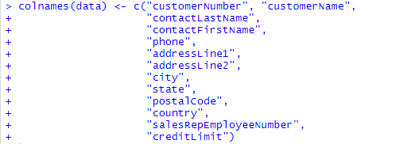

* Use write.csv to write this data back into your folder. Use a different file name so that you do not overwrite the original file.

Answer: The data was written into a different file and saved in the folder.



* Provide the following statistics of the file that you read above:
  + Dimension of the dataset – number of rows and column

Answer: We used the dim() function to display the dimensions of the data.



* + The datatypes for the various data elements – use sapply and class

Answer:

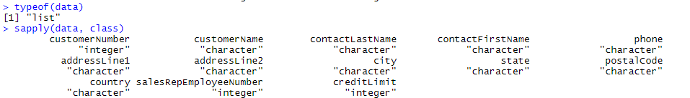

* + Compute the following:
    - The frequency distribution of the following variables: country and state

Answer: The below code shows the frequency distribution for the country variable.

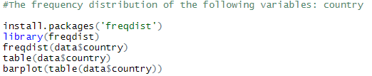

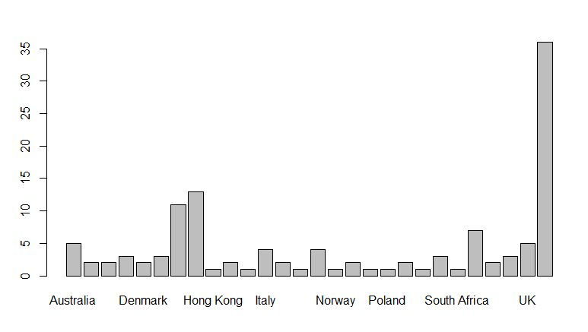

The below code shows the frequency distribution for the state variable.

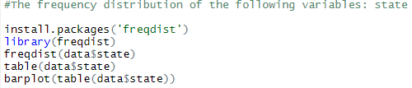

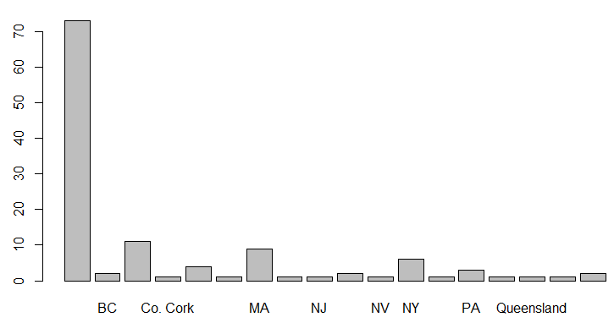

* + - Mean of the creditLimit

Answer: The mean of the creditLimit variable as seen through the mean() function is 68053.72 .



* + Display a summary of the data using the summary function

Answer: The summary of the data has been displayed using the summary() function.

